Thames View Junior School

Safeguarding and Child Protection Policy

Introduction

The governors and staff of Thames View Junior School fully recognise the contribution it makes to safeguarding children. We recognise that all staff, including volunteers, has a full and active part to play in protecting our children/young people from harm.

All staff and Governors believe that our school should provide a caring, positive, safe and stimulating environment which promotes the social, physical and moral development of the individual child/young person.

The aims of this policy are:

- To support the child’s/young person’s development in ways that will foster security, confidence and independence

- To raise the awareness of both teaching and non-teaching staff of the need to safeguard children/young people and of their responsibilities in identifying and reporting possible cases of abuse and of children in need.

- To provide a systematic means of monitoring children, known or thought to be at risk of harm.

- To emphasise the need for good levels of communication between all members of staff.

- To develop a structured procedure within the school, which will be followed by all members of the school community, in cases of suspected abuse.

- To develop and promote effective working relationships with other agencies, especially Children’s Services and the Police.

- To ensure that all adults within our school, who have access to children/young people, have been checked as to their suitability.

Procedures
Our school procedures for safeguarding children will be in line with the London Child Protection Procedures (LSCB http://www.londonscb.gov.uk/ ) (endorsed by Barking and Dagenham Safeguarding Children Board (BDSCB http://www.bardag-lscb.co.uk/Pages/Home.aspx)).

We will ensure that:
We have a designated senior member of staff (the Child Protection Coordinator) who undertakes regular inter-agency training and refresher training every 2 years.
- Thames View Junior School: Mr. H. Ramduth

We have a member of staff who will act in the designated person’s absence (the Deputy Child Protection Coordinator) and undertake appropriate training.
- Thames View Junior School : Miss S. Rider

We have a designated Governor (Designated Child Protection Governor: Meena Kishinani) who undertakes appropriate training.

All members of staff develop their understanding of the signs and indicators of abuse and have training at least every 3 years.

All members of staff know how to respond to a child/young person who discloses abuse.

All parents/carers are made aware of the responsibilities of staff members with regard to child protection procedures and the policy is made available to them.

Our policy and procedures will be reviewed annually and up-dated.

All new members of staff will be given a copy of our child protection procedures as part of their induction into the school.

Responsibilities

The designated senior member of staff Child Protection Lead (CPL) is:
Academic year | Child Protection Lead | Deputy CP leads | Nominated Governor | Chair of Governors
2015-2016 | Hans Ramduth | Sara Rider | Meena Kishinani | James Hodgson

The designated senior member of staff Child Protection Lead (CPL) is responsible for:

- Adhering to the London Child Protection Procedures and school procedures with regard to referring a child/young person if there are concerns about possible abuse or child in need.

- Keeping written records of concerns about a child/young person even if there is no need to make an immediate referral.

- Ensuring that all such records are kept confidentially and securely and are separate from pupil records.

- Ensuring that an indication of further record-keeping is marked on the pupil records.

- Ensuring that any pupil currently on the child protection register who is absent without explanation for two days is referred to Social Services.

- Ensuring that all school staff are aware of the School’s Safeguarding/CP policy and procedures, and know how to recognise and refer any concerns

- Providing an annual report for the Governing Body, detailing any changes to the policy and procedures; training undertaken by the Nominated Safeguarding Adviser, and by all staff and Governors; relevant curricular issues, number and type of incidents/cases and number of children referred to Social Services and subject to child protection plans (anonymised).

- Keeping themselves up to date with knowledge to enable them to fulfill their role, including attending relevant training, at least every two years.

Training

Training will be provided in order to ensure that:

- All staff are able to recognise how to identify signs of abuse

- Appropriate staff have a working knowledge of how Local Safeguarding Children Boards operate, the conduct of a child protection case conference and be able to attend and contribute to these effectively when required to do so

- All staff members have access to and understand the school’s child protection policy especially new or part time staff who may work with different educational establishments

- All staff members have induction training covering child protection and are able to recognise and report any concerns immediately they arise. (This is essential in respect of staff members that are part time or work with more than one school, such as trainee teachers and supply teachers).

- Appropriate staff are able to keep detailed, accurate, secure written records of referrals/ concerns

- All staff members have access to resources and attend any relevant or refresher training courses at least every two years.

Supporting Children

- We recognise that a child/young person who is abused or witnesses domestic violence/abuse may find it difficult to develop and maintain a sense of self-worth.

- We recognise that a child/young person in these circumstances may feel helpless and humiliated. We recognise that a child/young person may feel self-blame.

- We recognise that the school may provide the only stability in the lives of children/young people who have been abused or who are at risk of harm.

- We accept that research shows that the behaviour of a child/young person in these circumstances may range from that which is perceived to be normal to aggressive or withdrawn.
Priorities: When to be concerned!

All Staff should be concerned if a pupil:
- Has any injury not typical of the bumps and scrapes normally associated with children’s activities;

- Regularly has unexplained injuries

- Frequently has an injury, even when apparently reasonable explanations are given

- Offers confusing or conflicting explanations about sustained injuries;

- Exhibits significant change in behavior, performance or attitude;

- Indulges in sexual behavior, which is unusually explicit and/or inappropriate to his or her age;

- Discloses an experience in which he or she may have been significantly harmed.

Our school will support all children/young people by:

- Encouraging self-esteem and self-assertiveness whilst not condoning aggression or bullying

- Promoting a caring, safe and positive environment within the school.

- Liaising and working together with all other support services and those agencies involved in the safeguarding of children

- Notifying Children’s Services as soon as there is a significant concern.

- Providing continuing support to a child/young person about whom there have been concerns who leaves the school by ensuring that their child protection record is forwarded, under confidential cover, to the child/young person’s new school as soon as possible. (Copy retained).

Guidelines
Child abuse, particularly sexual abuse, can arouse strong emotions in those facing such a situation.

It is important to understand these feelings and not allow them to interfere with any judgement about the appropriate action to take or the response to the child disclosing information.

All personnel should be encouraged to demonstrate exemplary behaviour in order to promote children’s welfare.

It is not the responsibility of anyone working within the school, in a paid or unpaid capacity to decide whether or not child abuse has taken place.

However there is a responsibility to act on any concerns by reporting these to the appropriate person.

Certain governors and all staff have had appropriate child protection training, which is updated at least every three years.

The Child Protection Lead is Hans Ramduth (Assistant Head Teacher, Inclusion Manager, Child Protection Lead).
The deputy Child Protection lead is Miss S. Rider (Acting Head Teacher) and the designated governor is Mrs Meena Kishinani.

Confidentiality

We recognise that all matters relating to Child Protection are confidential.

The Headteacher or designated senior member of staff (CPC) will disclose any information about a child/young person to other members of staff on a need to know basis.

All staff must be aware that they have a professional responsibility to share information with other agencies in order to safeguard children/young people.

All staff must be aware that they cannot promise a child/young person to keep secrets.

Supporting Staff

We recognise that staff working in the school who have become involved with a child/young person who has suffered harm, or appears to be likely to suffer harm, may find the situation stressful and upsetting.

We will support such staff by providing an opportunity to talk through their anxieties with the designated senior member of staff (CPC) and to seek further support as appropriate.

We understand that staff should have access to advice on the boundaries of appropriate behaviour.

The document “Guidance on Safe Working Practices for the Protection of Children and Staff in Education Settings” provides advice on this, and the circumstances which should be avoided in order to limit complaints against staff of abuse of trust, and/or allegations of physical or sexual harm.

Allegations against staff

We understand that a child/young person may make an allegation against a member of staff.

If such an allegation is made, the member of staff receiving the allegation will immediately inform the headteacher.

The headteacher on all such occasions will discuss the content of the allegation with the Local Authority Designated Officer (LADO) for Child Protection, Mike Cullern (3934).

If the allegation made to a member of staff concerns the Headteacher, the member of staff receiving the information will immediately inform the Chair of Governors who will consult with the LAs Lead Officer for Child Protection.

The school will follow the LA procedures for managing allegations against staff, a copy of which will be readily available in the school.

All school staff should take care not to place themselves in a vulnerable position with a child.

It is always advisable for interviews or work with individual children or parents to be conducted in view of other adults.

All staff should be aware of the school’s behavior / discipline policy.

Whistleblowing

We recognise that children/young people cannot be expected to raise concerns in an environment where staff fail to do so.

All staff should be aware of their duty to raise concerns, where they exist, about the attitude or actions of colleagues.

Physical Intervention

Our policy on physical intervention/positive handling by staff is set out in a separate policy and acknowledges that staff must only ever use physical intervention as a last resort, and that at all times it must be the minimal force necessary to prevent injury to another person.

We understand that children who have experienced abuse may react in extreme ways to touch, and that there should be recognition of this.

We understand that physical intervention of a nature which causes injury or distress to a child/young person may be considered under child protection or disciplinary procedures.

Bullying

Our policy on bullying is set out in a separate policy and acknowledges that to allow or condone bullying may lead to consideration under child protection procedures.

Racist Incidents

Our policy on racist incidents is set out in a separate policy and acknowledges that repeated racist incidents or a single serious incident may lead to consideration under child protection procedures.

Prevention

We recognise that the school plays a significant part in the prevention of harm to our children/young people by providing children/young people with good lines of communication with trusted adults, supportive friends and an ethos of protection.

The school community will therefore:

Establish and maintain an ethos where children/young people feel secure and are encouraged to talk and are always listened to.

Ensure that all children/young people know there is an adult in the school whom they can approach if they are worried or in difficulty.

Include in the curriculum opportunities for PSHE&C which equip children/young people with the skills they need to stay safe from harm and to know to whom they should turn for help.

Health & Safety

Our Health & Safety policy, set out in a separate document, reflects the consideration we give to the protection of our children/young people both within the school environment and when away from the school when undertaking school trips and visits.

Appointment of Staff

Our safe recruitment policy, set out in a separate document, acknowledges our responsibility for protecting children from unsuitable people through safe recruitment practices.

Child Protection Procedures

The DfE document “Safeguarding Children in Education” provides the legal framework for the protection of children in the UK.

In addition, “The London Child Protection Procedures” document is applicable throughout London.

Schools are also expected to ensure that they have appropriate procedures in place for responding to situations in which they believe that a child has been abused or is at risk of abuse – these procedures should cover circumstances in which a member of staff is accused or suspected of abuse.

Staff should be concerned if a pupil:
- Has any injury which is not typical of the bumps and scrapes normally associated with children’s activities;

- Regularly has unexplained injuries;

- Frequently has injuries, even when apparently reasonable explanations are given;

- Offers confused or conflicting explanations about how injuries were sustained;

- Exhibits significant changes in behaviour, performance or attitude;

- Indulges in sexual behaviour, which is unusually explicit and/or inappropriate to his or her age;

- Discloses an experience in which he or she may have been significantly harmed.

- Appears neglected i.e. the child’s basic physical and/or psychological needs are not being met. This may involve failure to provide adequate food, shelter or clothing, failure to protect from physical harm or danger or failure to ensure access to appropriate medical care or treatment. It may also include neglect of a child’s basic emotional needs.

School Procedures

Awareness of issues relating to safety is dealt with during assemblies and PSHE.

Any member of staff may raise minor concerns about a child with the Child Protection Lead or Deputy Child Protection Coordinator.

The Headteacher or CP Lead will bring any significant concerns to the notice of Social Services.

Any issues relating to child protection should be discussed with the Headteacher.

Any decision about contacting other agencies is the responsibility of the Headteacher or CP Lead.

- Any member of staff with immediate concerns about a child must inform the Child Protection Lead or Deputy Child Protection Lead.

- The member of staff must record information regarding the concerns on the same day. The recording must be a clear, precise, factual account of the observations and must be given to the Child Protection Lead.

- The Child Protection Lead will decide whether the concerns should be referred to the Social Services. If it is decided to make a referral to Social Services the parents will be consulted unless, by seeking their consent, we put the child at risk of further harm.

- If a referral is made to Social Services, the Child Protection Lead will ensure that a written report of the concerns is sent to the Social Services Department (Worker dealing with the case ) within 48 hours.

- Particular attention will be paid to the attendance and development of any child who has been identified as at risk, or who has been placed on the Child Protection Register.

- If a pupil who is on the Child Protection Register or the school has records concerning child protection issues and the child then changes school, the Child Protection Lead will inform the Social Worker responsible for the case and transfer the appropriate records to the receiving school.

Dealing with a disclosure:

Inform the CP Lead immediately:
If a pupil discloses that he or she has been abused in some way, the member of staff should:

- Listen to what is being said without displaying shock or disbelief;

- Accept what is being said;

- Allow the child to talk freely;

- At no time must a member of staff question, in depth, a child suspected of being abused;

- Reassure the child, but not make promises which it might not be possible to keep;

- Not promise confidentially, as it will be necessary to tell the Child Protection Lead and it might be necessary to refer the case to Social Services;

- Reassure the pupil that what has happened is not their fault;

- Stress that it was the right thing to tell;

- Listen, rather than ask direct questions;

- If required, ask open questions. Never ask leading questions;

- Not criticize the perpetrator;

- Explain what has to be done next and who has to be told;

Record keeping
When a pupil has made a disclosure, the member of staff should:

- Make some brief notes as soon as possible after the conversation;

- Not destroy the original notes in case they are needed by a court;

- Record the date, time, place, and any noticeable non-verbal behaviour, the words used by the child and anything said by the member of staff and pass directly;

- Draw a diagram for the Child Protection Lead;

- Indicating the position of any bruising or other injury;

- Record factual statements and observations, rather than interpretations or assumptions.

This policy and procedures are underpinned by the following documents:
LA Procedures for Allegation against Staff

LA Whistle blowing policy

LA Physical intervention/Positive Handling policy

The schools Bullying policy The schools Racial policy

The schools Health & Safety policy

The schools Pupil Behaviour Welfare policy

LA Safe Recruitment policy Safeguarding Children in Education Framework

The London Child Protection Procedure

ECM Agenda

Thames View Junior School

Confidential Information
Name of the Person completing this form: |  |  |  |  | Signature:
Date |  |  |  |  | Time:
Full Name of Child: ______________________________________________________
Date of Birth: Class:
Information Given By: (Please Specify)
Child |  | Another Child |  | Child minder |  |  |  | Parent
Staff Member |  | Another Parent |  | Other
CONTEXT: (Where and When)

EXACT DETAILS: (Please use facts and be as precise as possible)

Date Received
Action Taken
Name: |  | Signature: |  |  |  |  | Date:
Appendix A
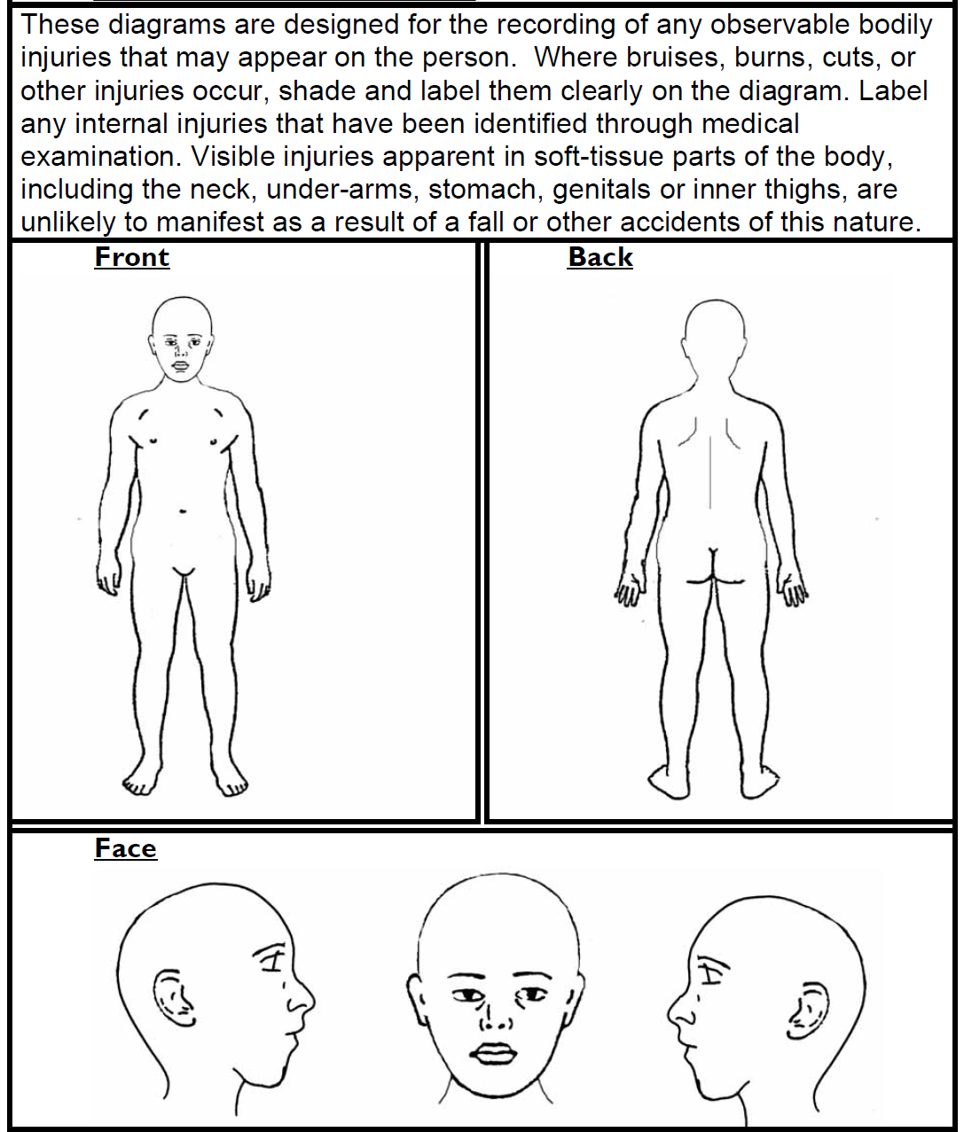

Date and time:

Signature:
Appendix B
If you’re worried about a child

Complete a Confidential Form

Hand it in to the CP Lead
Hans Ramduth

If the CP Lead is not available – Hand it in to the
Acting Head Teacher Sara Rider

Child Protection Lead / Headteacher decides next steps

MARF sent to Children’s Services
School based support provided

USEFUL CONTACT NUMBERS

Triage Team (8.45-4.45) ……………………………………………- 0208 227 3852
/3882/5048
Emergency Duty Team (out of hours)………………………– 0208 594 8356
Police Child Abuse Investigation Team (CAIT)………– 0208 345 2957
LADO (Mike Cullern)………………………………………………….…- 0777 222 9261
Child Protection Lead (H.Ramduth)…………………………..-0208 270 4947
Deputy Child Protection Lead (S.Rider)…...................- 0208 270 4310

Useful Websites:
http://www.londoncp.co.uk/
http://www.bardag-lscb.co.uk/Pages/Home.aspx
http://www.safenetwork.org.uk/training_and_awareness/pages/lscbs.aspx
https://www.ceop.police.uk/
https://www.thinkuknow.co.uk/
http://www.londonscb.gov.uk/procedures/
http://www.npscc.org.uk

