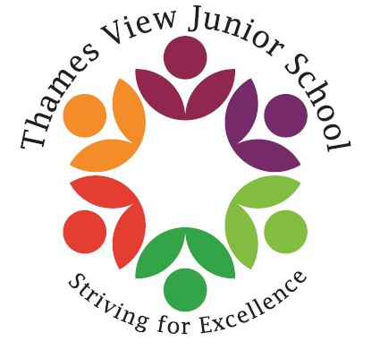

Headteacher: Sara Rider
Assistant Headteachers:
Hans Ramduth, Rebecca Seaton,
Rachel Mottershead,
Georgina Nixon

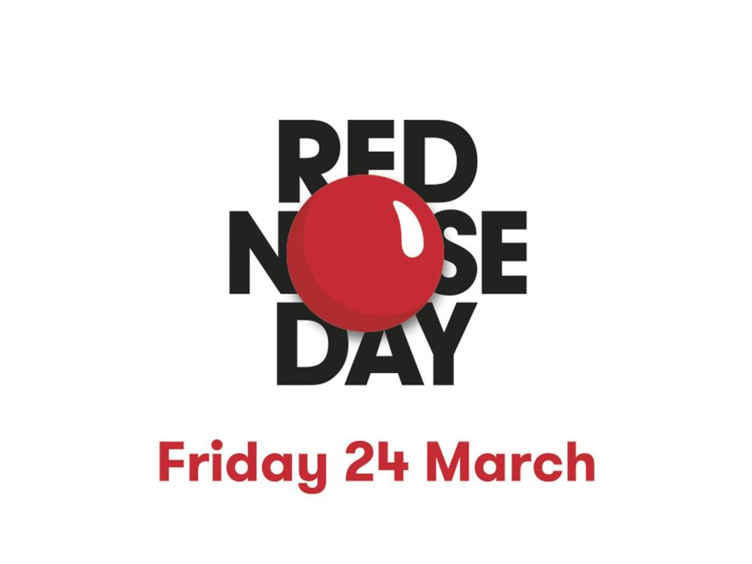
Thursday 16th March

Sara

Dear Parents,
Dear Parents,
As you have probably seen on the television, Comic Relief’s Red Nose day is next Friday 24th March. This year we are giving the children the option to make themselves ‘Funny for Money’ or come into school in non-uniform. There will be prizes for the ‘funniest children!’
As it is a wonderful charity, we ask that the children donate £1 if they are coming into school either dressed up or in non-uniform.
As with any good Thames View Junior event. The ice cream man will be visiting us in the afternoon, for a well- earned sweet treat and excess strawberry and chocolate sauce!
Red noses are optional but encouraged as is face paint, wild hair, and weird and wonderful clothing!

Best Wishes

Sara Rider

