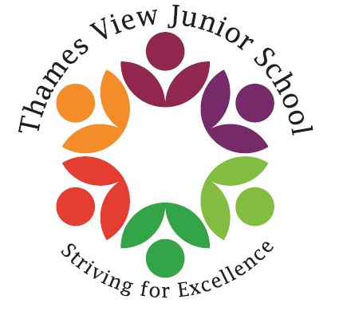

Headteacher: Sara Rider
Assistant Headteachers:
Hans Ramduth, Rebecca Seaton,
Rachel Mottershead,
Georgina Nixon
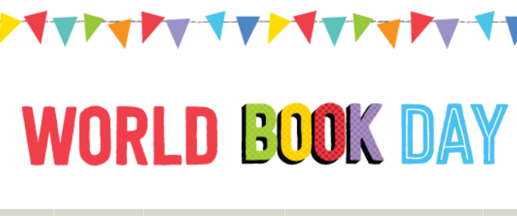

Dear Parents,
Welcome back! I hope that you all had a lovely half term. The children came back into school on Monday full of excitement and raring to go!
Next week is book week at school. My favourite week of the year! The children will all be learning about an author and taking part in interesting and engaging book related activities.
We will also have a professional artist in school next week, Adam Pryce who will be working with the children to transform our library space into a jungle scene from the book Where the Wild Things Are. We are very excited to see what the final outcome will be!
Of course, book week will culminate on Friday with our World Book Day Fancy Dress Celebration. We will have prizes for the most imaginative outfits as well as a book raffle for the children. Tickets for the raffle will go on sale on Monday 27th February and will cost 20p a ticket or £1 for a strip.
The ice cream man will also be in school and we will be running a tuck shop. All money raised from the tuck shop will go into supporting the school. More information will follow on this.
So, get your creative thinking hats on and ready for Friday! Looking forward to seeing the wonderful book related costumes!
Best Wishes,

Sara

