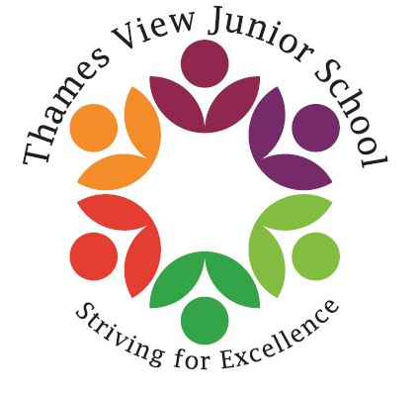

Headteacher: Sara Rider
Assistant Headteachers:
Hans Ramduth, Rebecca Seaton,
Rachel Mottershead,
Georgina Nixon

Friday 9th March 2018

Dear Parents,
As the year progresses we will be holding different fundraising events in Year 6 that will lead us to our end of year prom.
From now until July, we will have different fundraising events. The money collected from each event will be used towards funding our prom, preventing children from having to pay for tickets.
The first event will be a cake bake sale on Friday 16th March.
We ask that you please provide your child with either bought or homemade goods that we can use for the sale. Each child will be allowed to bring up to £2 on that day so they can purchase baked goods. These goods will be sold to children from all year groups during their break times on Friday.
We will keep you updated on the success of our first event and look forward to organising more!
Thank you for your cooperation,
Year 6 team

